Introduction
The Shadowmoon Burial Grounds is one of the new 5 man dungeons that was released with Warlords of Draenor and can be located in Shadowmoon Valley on Draenor. In total this dungeon has got four bosses, all of which can be accessed on Normal, Heroic and Challenge difficulties. The heroic mode encounters are fairly similar to the normal mode encounters however there are some differences in abilities and damage that the bosses abilities deal. In this guide you will be able to find information such as boss abilities, boss loot and also a guide for each of the separate boss fights. Look out for the Heroic Mode icon throughout this guide to see what differs on the Heroic mode versions of these encounters.
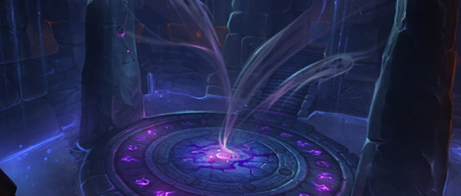

General Information
Below you are able to view a range of general information about this dungeon such as its map, any related video guides we may have put out and also any achievements that you are able to earn.

Maps
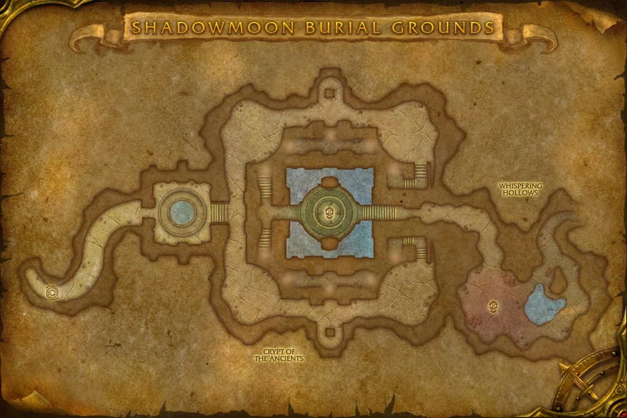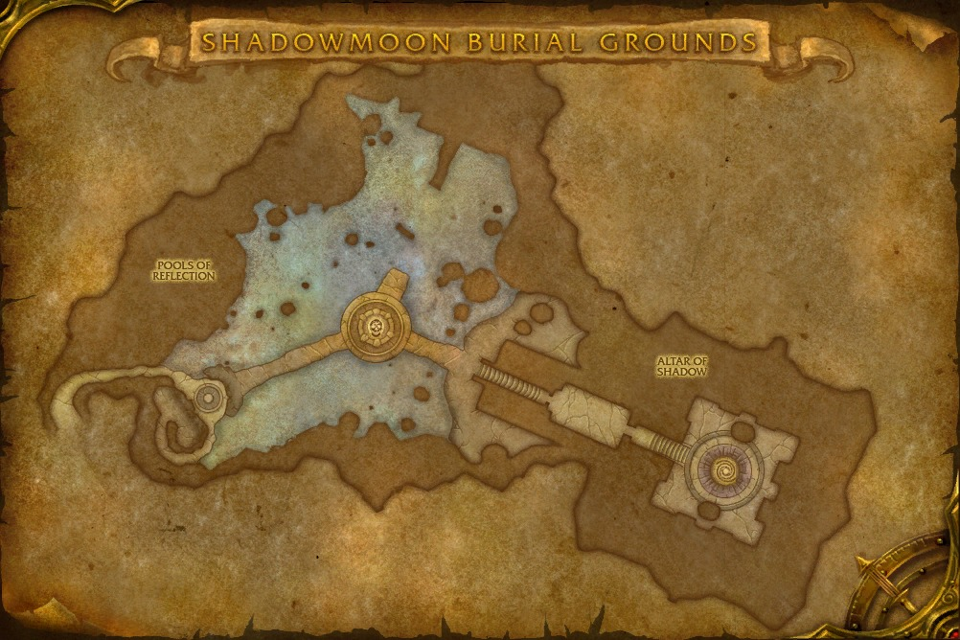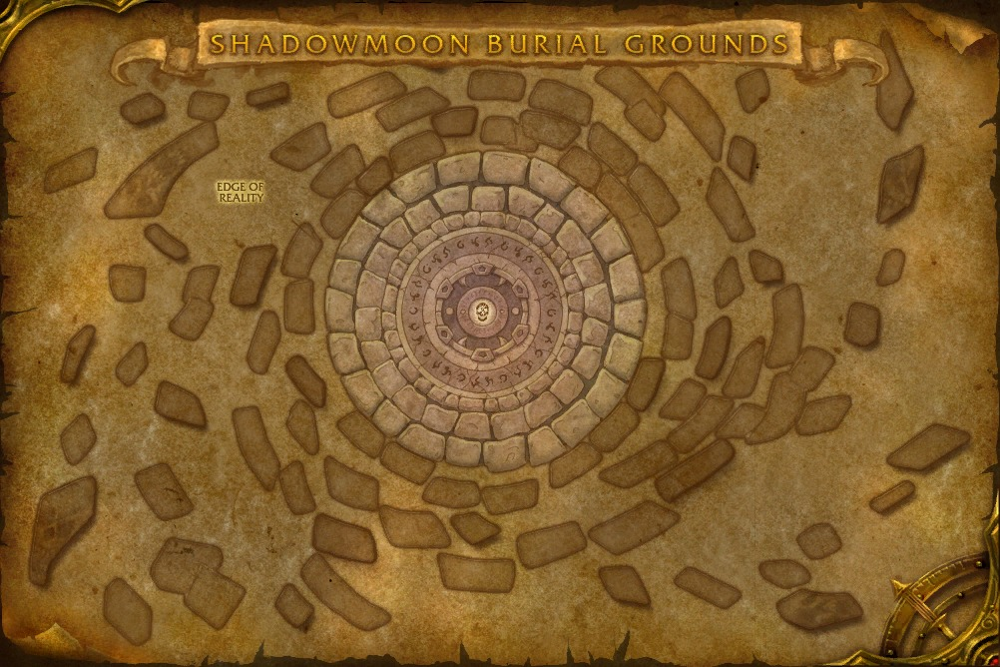
This dungeon is an inside environment with different levels on which you can fight bosses. The first boss that you are going to come up against is Sadana Bloodfury who can be accessed after clearing several trash mobs and by dropping down a few levels from where you first entered the dungeon. Once she has been taken care of you will follow the dungeon through and be taken up slightly to the next boss who goes by the name of Nhallish. Once this beast has been taken down you will have to fight your way through a few spider packs in order to be taken to Magmaw’s lookalike who goes by the name of Bonemaw. Once he has been taken out you can then proceed onto the final boss in this dungeon who goes by the name of Ner’zhul.

Boss Voices
Below is a video of the boss audio files that you will hear throughout this dungeon.

Videos

Achievements

Achievement Name | Requirements
Shadowmoon Burial Grounds Challenger | Complete the Shadowmoon Burial Grounds Challenge Mode.
Shadowmoon Burial Grounds: Bronze | Complete the Shadowmoon Burial Grounds Challenge Mode with a rating of Bronze or better.
Shadowmoon Burial Grounds: Silver | Complete the Shadowmoon Burial Grounds Challenge Mode with a rating of Silver or better.
Shadowmoon Burial Grounds: Gold | Complete the Shadowmoon Burial Grounds Challenge Mode with a rating of Gold.
Shadowmoon Burial Grounds | Defeat Ner’zhul in Shadowmoon Burial Grounds.
Heroic: Shadowmoon Burial Grounds | Defeat Ner’zhul in Shadowmoon Burial Grounds on Heroic difficulty.
Heroic: Shadowmoon Burial Grounds Guild Run | Defeat Ner’zhul in Shadowmoon Burial Grounds on Heroic difficulty while in a guild group.
Challenge Master: Shadowmoon Burial Grounds | Attain a realm-best time for the Shadowmoon Burial Grounds Challenge Mode.
Icky Ichors | Defeat Bonemaw after having fed him 25 Corpse Skitterlings in Shadowmoon Burial Grounds on Heroic difficulty.
What’s Your Sign? | Defeat Sadana Bloodfury while only having the runes that correspond to her active lunar cycle lit in Shadowmoon Burial Grounds on Heroic difficulty.
Souls of the Lost | Defeat Ner’zhul after slaying 2 Ritual of Bones skeletons within 5 seconds of each other in Shadowmoon Burial Grounds on Heroic difficulty.

Bosses

Sadana Bloodfury

The first boss in this dungeon goes by the name of Sadana Bloodfury. She will cast several Shadow based abilities at your party in order to try and bring you down and stop you from progressing in this dungeon.
Sadana stands at the center of a ritual circle, calling down dark energies to assault her enemies and attempting to absorb the life force of nearby spirits to heal herself when she is injured.

Abilities
- Deathspike – Successful melee attacks have a chance to grant three additional melee attacks which inflict 45,000 Shadow damage.
- Dark Communion – Beckons a spirit towards the caster, consuming them if they get within range. If devoured, this unit heals the caster for 40% of their life, and increases their damage done by 20%.
- Daggerfall – Sadana conjures a sacrificial dagger over a random player, inflicting 120,000 Shadow damage on impact. The dagger remains in the ground, burning players within 4 yards for 40,000 Shadow damage per second.
- Whispers of the Dark Star – Inflicts 20,000 Shadow damage to all enemies every second.
- Dark Eclipse – Channels a Dark Eclipse, inflicting 400,000 Shadow damage to all players, and corrupting Lunar Runes.
  - Lunar Purity – Lunar rays of purity bathe you in a divine light, decreasing damage taken by 80%.

Guide

The first ability that you are going to have to deal with in this dungeon is Deathspike and this is one mainly for your healer and your tank to deal with. When Sadana attacks she has a chance to cast three more attacks on the tank dealing a high amount of Shadow damage. Your tank will simply need to use a cool down when this happens and your healer must be ready to heal through the damage or use one of their cool downs on the tank in order to keep them alive. Sadana will also periodically cast an ability called Whispers of the Dark Star which will cause everyone in the party to take shadow damage every second. Again this is something that you have got to simply heal through or use cool downs for. If you have a healer that is capable of AoE healing, such as a Restoration Druid, then you will be better off stacking up in order to try and maintain high group healing.

Sadana’s next ability is going to be randomly targeted on a player in the group and is called Daggerfall. This will cause her to spawn a dagger above a player and it will begin to fall down to the ground. You simply want to move away from this as fast as possible as it will deal a high amount of Shadow damage when it lands and will also deal damage to anyone that is within 4 yards of it when it does land. You will want to be aware of where you position these as several of them could be up at any one time which will cause issues when it comes to moving yourself around the room.

Sadana will also cast an ability called Dark Communion. This will cause her to spawn a spirit that is linked to Sadana that will begin to move towards her when it hits the ground. If the spirit is to reach Sadana then it will heal her and also give a damage increase. You simply need to DPS the spirit down as fast as possible when it spawns and also use any stunning or slowing abilities that you may have in order to give you more time to deal damage to the spirit as it moves towards the boss.

The final ability that Sadana is going to cast is called Dark Eclipse and this will cause her to spawn a Dark Eclipse over the room that will deal a very high amount of damage to everyone that is in your party. Thankfully there are little white orbs around the room that spawn when this occurs, called Lunar Purity, which you are able to stand in to decrease your damage taken by 80%. Simply move into one of the Lunar Purity orbs when the Dark Eclipse begins and your healer should be able to heal through the decreased damage that you are going to take.

Nhallish

The second boss that you will go up against in this dungeon goes by the name of Nhallish. Throughout the fight he will banish you to the shadows in order to try and defeat you before you get the chance to kill him and advance in this dungeon.
Nhallish raises spirits to attack his foes, calls down blasts of void energy, and periodically banishes all players to a spectral realm where they must defeat and recapture their own souls to escape.

Abilities
- Planar Shift – The caster twists the flow of void energy around himself, preparing to teleport towards an enemy within 150 yards.
- Void Vortex – A powerful vortex pulls enemies towards the center, inflicting 30,000 Shadow damage each second.
- Void Blast – A dark energy tears at your flesh, inflicting 90,000 Shadow damage every second.
- Void Devastation – Channeling a dark energy, launching bolts of Shadow magic for 15 sec.
- Soul Shred – Nhallish periodically tears players’ spirits from their bodies, dealing damage until they subdue and recapture their soul.
  - Soul Shred – Tears the soul from an enemies body, inflicting 8,000 Shadow damage every 1 sec. enemies who recapture their soul within 20 sec, you will be empowered by Returned Soul.
  - Returned Soul – Successfully recovering your soul empowers you, increasing all damage and healing done by 40% for 20 sec.

Guide

The first ability that you are going to have to be aware of in this dungeon is Planar Shift. While this ability doesn’t actually deal damage to any players, it will cause Nhallish to position himself in a place which could cause issues when his next ability, Void Vortex, is cast. While this is being cast you simply need to run away from Nhallish in order to out range the damage that he will be dealing to your party. The use of speed increasing abilities will prove to be very helpful at this point in the fight.

The next ability that you will need to be aware of, and this is mainly for your tank, goes by the name of Void Blast. This is a frontal cone ability that will deal damage to anyone that is standing in front of Nhallish when it is being cast. Your tank will simply need to make sure that the boss is not facing the party while this is going off and may need to consider using a cool down in order to negate some of the damage that it will deal.

During the fight Nhallish will cast an ability called Void Devastation which will cause him to spew out shadow bolts and create a range of purple shadow void zones on the ground. These zones will be marked on the ground before the shadow bolts land so you will simply need to move away from the location or you will take damage. You should also ensure that you are not standing in any of the void zones when they have spawned as you will also take damage from them then.

The final ability that you will have to deal with in this fight is called Soul Shred, and this will cause Nhallish to rip your soul from your body and phase you into a room where you are with a hostile version of yourself. During this time you will take periodic damage every second, from Soul Shred, so you will need to kill the hostile version of yourself as soon as possible, unless you have self heals. If you kill the spirit of yourself within 20 seconds you will then be taken back to the boss where you will be granted the Returned Soul buff which will increase your damage dealt and healing done by 40% for 20 seconds. If you don’t kill your spirit then you will simply be teleported back without any damage increase, that is if you don’t die to the ticking damage that you will be taking. It’s worth noting that once you kill the spirit you will have to interact with it, by right clicking it, in order to be returned back to the boss.

Bonemaw

The second to last boss in this dungeon goes by the name of Bonemaw who will both spray your raid with deadly abilities while trying to inhale your towards himself in order to defeat you and stop you from getting to Ner’zhul.
Bonemaw smashes his massive frame across the platform to crush his foes, as lesser carrion worms rise from the depths. Periodically, Bonemaw attempts to inhale all players with powerful suction.

Abilities
- Necrotic Pitch – Bonemaw spews a Necrotic Pitch over a random player’s location, inflicting 18,000 Shadow damage every second and reducing movement speed by 75%.
- Corpse Breath – Inflicts 20,000 Shadow damage to all enemies every second.
- Fetid Spit – Bonemaw slimes his current target with a fetid spit, inflicts 90,000 Nature damage to the enemy target. If he has no valid targets in melee range, he will spit uncontrollably.
- Body Slam – Bonemaw thrusts his body forward, inflicting 200,000 Physical damage to enemies in front of him and knocking them back.
- Inhale – Inhales enemies at an increasingly powerful rate. If a player is caught in his deadly maw, they suffer 195,000 Nature damage and are removed from the platform.
- Carrion Worm
  - Fetid Spit – Inflicts 60,000 Nature damage to the enemy target. If left without any valid melee targets, this unit will spit uncontrollably.

Guide

The first ability your healers will need to be aware of in this encounter goes by the name of Corpse Breath. This will cause Bonemaw to deal damage to everyone in the party every second. This is something that your healers will need to simply heal through and the use of personal and party wide cooldowns should be used if needed in order to keep people alive. Bonemaw’s next ability, Fetid Spit, means that throughout the fight there must always be someone in melee range. You will find that from time to time he will hide and then appear in a different place on the platform. You want to have your tank be near him as soon as possible so that he only casts Fetid Spit on the tank and not everyone that is in the party.

The next ability you should be aware of is Necrotic Pitch. This will cause you to take damage every second when you are standing in it and will also reduce your movement speed by 75%, so naturally you want to move from it. However there is an exception. When Bonemaw casts Inhale you will want to go and stand in one of these patches as it will root you in place and stop your from being pulled towards Bonemaw. If you do get inhaled by Bonemaw then you will take a high amount of damage and also be thrown off the platform.

Throughout the fight Bonemaw will also cast Body Slam which will cause him to slam himself into the platform and deal a high amount of damage to whoever he hits whilst also knocking them back. You simply need to move away from this and not get hit by it. The area is marked with a massive purple line on the ground so it is easy to see and move away from. Finally when Bonemaw retreats and then comes back up he will also spawn several Carrion Worms. You will simply need to avoid the Body Slam that they cast and also have someone stand near them in order to take the damage from Fetid Spit. Ideally your tank should be able to position themselves in melee range of both Bonemaw and the Carrion Worms. You should keep on damaging Bonemaw when the Worms spawn and simply avoid their abilities.

Ner’zhul

The final boss in this dungeon is Ner’zhul, and despite being the last boss he has only got 3 abilities that he is going to try and bring you down with all of which are fairly easy to deal with.
Ner’zhul, chieftain and elder shaman of the Shadowmoon clan, sacrificed the heart and soul of his tribe in an attempt to join the Iron Horde. He has now retreated to his clan’s ancient burial grounds as he ventures ever further along a dark path, embracing the power of the Void and the necromantic arts.

Abilities
- Malevolence – Ner’zhul casts a shadow of void energy, inflicting 225,000 Shadow damage to all enemies in a line in front of him. Afflicted players will have their damage reduced by 50%
- Omen of Death – Ner’zhul falls into a trance, showing players a vision of their own death. Void energy rips through the sky, inflicting up to 70,000 Shadow damage, based on proximity to the effect.
- Ritual of Bones – Ner’zhul summons an army of shadow and death which marches across his platform, eradicating all life in its path.
Tendrils of void bind the ritual bones together, inflicting 70,000 Shadow damage per second to those who cross their threshold.

Guide

The first ability that you are going to have to deal with in this fight is a frontal cone ability that goes by the name of Malevolence. This ability will be cast in front of him and there is a very short cast time on the ability, but it is long enough for you to be able to move out of the way of it. If you do happen to be hit by Malevolence then you will take a fatally high amount of damage, which you might just be able to survive, and will also have your damage dealt reduced by 50%.

The next ability that you are going to have to deal with is going to be targeted onto specific players, and they are then going to have to move away from it to not take additional damage. This ability goes by the name of Omen of Death. Once the purple void zone has spawned then you you will not be able to go near it without taking a high amount of damage. The further you are from the purple void zone, the less damage you are going to take.

The final ability that you are going to have to deal with during this encounter has the potential to kill everyone in your party in an instant if it is not dealt with in the correct manner. This ability is called Ritual of Bones. This will cause Ner’zhul to summon an army of shadow and death that spans the width of the platform you are on and will slowly begin to move from one side to another. Within this wall of death there are skeletal adds which you can target. What you want to do is, ideally mark one of them with a skull for killing, focus down one of the adds in order to break the wall that is moving towards you so that it creates an opening you can stand in or move through in order to be safe when the wall passes you.

